CNC – Computer Numerical Control

1. Introduction

CNC means computer numerical control. It could well have been computer control. For that matter, any form of control with the aid of computers can be termed as computer control (Incidentally, the discussion here would be restricted to computer control of Machine Tools). Actually, in the early stages of computer control of machine tools, the controlling element was not a full fledged computer in the true sense of the term, but an assortment of hardwired logic circuits where control was achieved by giving instructions to the machine in alpha-numeric (letters and numbers) code or format. This is the principal reason why it was called Numerical Control or just NC. Even when proper computers with hardware and software facilities started getting incorporated for machine tool control, the same numerical code continued to get used more out of convention than necessity. Thus, the control method was christened Computer Numerical Control or just CNC.

A variety of machine tool control systems were already in existence when NC came into being. These systems enabled automatic control of machine tool operations. These employed different strategies of control like mechanical, electrical, hydraulic, electronic and a variety of other conventional forms of control. However, most of them were of fixed type and were not amenable to changes. Of course, the question arises : why should we, in the first place, be eager to change a control set-up which we are so painstakingly incorporating ?

Herein lies the primary reason for the advent and rise of NC. All the above mentioned and conventional strategies of automatic control, namely mechanical, electrical, hydraulic control etc, are difficult to change, i.e., inflexible. Applications that require the repeated use of the same control set-up operate quite well with such fixed type automation. One good example is mass production. In mass production, the very same product is made in large numbers over an extended period of time. Flexibility is neither required nor desirable in such set-ups.

In mass production, the conventional strategies of automation serve their purpose quite well. However, most of the production in the world today is in small lots and batches with the lot size remaining within 50 to 75 pieces. In small lot and batch production, there was no applicable strategy of automatic control which was cost effective. Manually operated machines with skilled operators were employed in such cases. However, manually operated machines are not always adequate for manufacturing the products with the required degree of accuracy, neither do they attain the desired level of productivity.
So, in a nutshell, there were various strategies of automation existing for machine tool control but none were flexible. They could not be changed very easily. If changes were imperative, that is, unavoidable, then a substantial amount of money, labour and time had to be expended in order to bring about those changes. It would be appropriate to include a simple example of automatic control at this point.

Let us consider the case of a cutting tool which is supposed to move with constant velocity (i.e., constant feed) forward and then retract fast (quick return). This has to be achieved automatically. One possible way is by incorporating a "CAM" (fig 1.1). The cam is a mechanical device which might typically be a plate with a near-disc like shape. It rotates about a shaft and has a follower that undergoes linear motion due to the radial movement it receives from the cam.

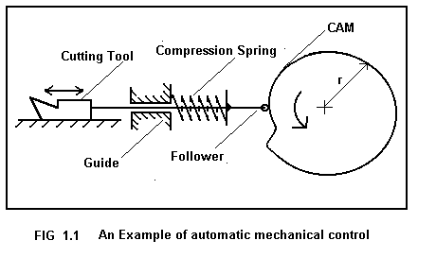
If constant linear velocity of the cutting tool is required, v = dr/dt = constant. Now, if the cam rotates with uniform circular motion, we can integrate as follows :

= k where k is a constant
dr = k . dt = k₁ .dθ as θ is proportional to time t (uniform circular motion)
Now, = k₁ θ
Or, r = k₂ + k₁ θ where k₂ is a constant

Which shows that the profile of the cam has to be an Archimedean spiral. Hence, the requirement of the problem can easily met by applying automatic mechanical control.

Now comes the question of change. If the extent of motion of the tool is now changed for some reason, we would have to change the cam. The cam assembly would have to be dismantled, the existing cam has to be scrapped, a new cam has to be designed and drawn. A cam blank has to be prepared and the cam has to be machined out on a milling machine. Last of all, the new cam has to be fit in place of the old one and assembled with the follower in position. This would be costly, laborious and time taking. This typically points out the problem associated with the inflexibility of mechanical and other conventional strategies of control employed in case of machine tools.

In comparison to these strategies, numerical control essentially controls machines by programs, i.e., a few lines of instructions. In case of changes, rewriting those software programs hardly requires any effort, time or expenses (this is, ha ha ha, not very true, considering the money you have to shell out nowadays to companies who write CNC software programs for you). Anyway, no physical devices like jigs, fixtures, cams, templates need to be changed or shifted, no application of manual or machine power is required for the incorporation of such changes.

At this juncture, it might be pointed out that numerical control was a evolutionary feature in the history of machine tools just as language was a feature in the evolutionary history of Living things. Previous to the advent of language, living things, especially higher mammals and even prehistoric men used to have sign language and a number of sounds as the only mode of communication. Various kinds of emotions, like love, hate etc were perhaps conveyed by various signs and even physical acts (smiles, clubbing on the head etc). In the case of machine tools as well, before the CNC machines, there was no sophistication in the communication of instructions to the machine. Physical devices employed for controls are similar in sophistication to physcial acts used for conveying information. Hence, the start of articulated speech, which brought about a galactic change in the evolution of humans, is similar to the advent of programmed NC machines, which brought a similar change in machine intstruction and communication. Machines could now be "talked to", the need for 'goading' a machine by physcial instructions (e.g., cams) were not necessary anymore.

Apart from this flexibility, CNC machines also have the ability to cut complex profiles. This is not a coincident or chance capability of computer controlled machines but a necessary requirement. Automation essentially requires that machine motions be provided by the controls. Thus, all the motions of the machine in computer control have to be generated with the aid of the computer. In case of mechanical automation, these very motions are obtained through physical devices like cams and followers, leadscrew and nut pairs, templates and tracers; in electrical automation, through limit switches and plugboards; in hydraulic controls, through valves and pistons. So, whenever complex contours were to be produced on a job, some physical device (like those mentioned above) used to be incorporated and make the tool move in its required path. Needless to say, all this application of hardware made these processes inflexible. So, in computer control, there cannot be any such physical devices because physical devices are hard to change. Hence, complex contours were dealt with in a different and novel manner depicted below.

In conventional machine tools, one prime mover satisfactorily provides power to all the motion elements of the machine tool. For example, on the lathe, the spindle is made to rotate by belt-pulley and gear connection from the motor while feed motion is obtained from the spindle itself. In other words, one motor supplies all the power. In the milling machine, the same motor provides cutting speed (cutter rotation), and feed (table movements). There is, of course, the rapid traverse motor, but that in most cases is used 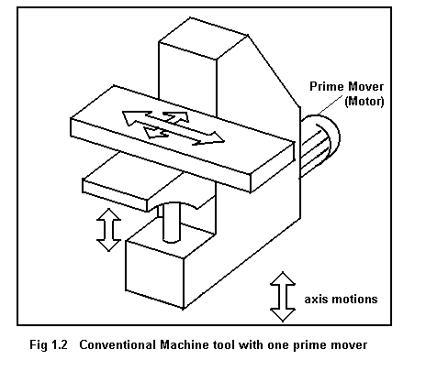for locating or moving the cutter to some location relative to the work piece.

So, in most cases, machine tools have one motor serving all movement elements of the machine.
In CNC machines, in order to cope with the problem of cutting out complex profiles, the very architecture of the machine is changed. Instead of having one motor serving all the speed and feed drives, separate and individual motors are incorporated in every drive. For example, in CNC milling, one motor is used for x motion, one for y motion and one for z. The cutter speed is obtained from yet another motor.
A profile is traced out by the relative motion of the cutter with respect to that of the work piece. The cutter motion is composed of its x, y and z components. Thus, if the instantaneous x, y and z velocities of the cutter be provided to it along the respective axes, its resultant motion would be the desired one along the appropriate direction. This is the basic working scheme of the CNC machine to generate complex profiles.
Every axis of motion in the CNC machine has a motor attached to it. The motor rotates the lead screw through a fixed reduction gearing and the lead screw moves the table through a nut. Thus this ‘dedicated’ motor provides the cutter with its required velocity component in that axis direction.
These motors can be controlled by the CNC machine controls by providing a definite voltage to them. If a specific velocity is required, a particular voltage is applied across the motor. Thus, if a cutter has to take a linear cut in the x-y plane whose direction makes an angle of 30 with the x axis, voltages proportional to cos 30 and sin 30 need to be given to the x and y motors (assuming, for the
time being, that applied voltage on motor is proportional to its angular speed). This would make the cutter move in the correct direction. If a circular cut needs to be taken, the x and y motors are provided voltages proportional to cos θ and sin θ where theta constanly changes with time. Thus, in profiles of any type and any degree of complexity, this simple method of path tracing is found to be suitable and satisfactory. The voltages which are sent to the motors are controlled by signals which are developed by the machine controls. These signals are developed from the program which is fed into the machine.
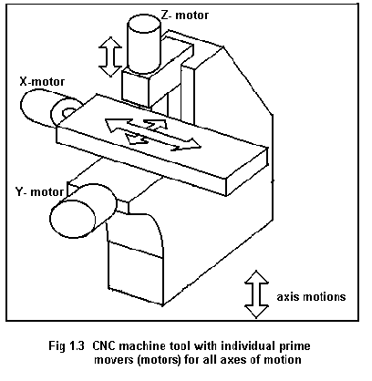
One question would natuarally appear in the minds of the readers, how are the axial velocities controlled in conventional machines ?
Well, in conventional machines, say in general purpose machine tools, velocity along different axes, in other words, feed motion, is controlled by gearboxes (in case of automatic motion).
If feed has to be changed, discrete options are available within a definite range. These are obtained by different settings in the feed gearbox of that machine. That is why, the range and number of feeds available with a machine are very important specifications. In CNC machines, the number of feeds available is practically limitless. It has to be so, as it is by the combination of the feed velocities along the different axes that velocity in a particular direction is obtained and profiles are cut. If feed value can be chosen arbitrarily, any direction of cut can be obtained. It is thus that the CNC machine cope with the problem of complex profile generation.

CNC machines produce jobs with high accuracy and repeatability, that is, precision. This results in higher productivity (number of acceptable goods produced per unit time). In mass production of fitting parts, a wider tolerance is permissible due to interchangeability of parts. This is not so in small lot and batch production and a tighter or closer tolerance level has to be maintained. Hence, CNC machines have to produce jobs of high accuracy.

To sum up, it should be mentioned that CNC is not the all-encompassing answer to the manufacturing scenario of the day. Fixed type automation has its own place and CNC can never be a substitute of fixed automation in case of large volume of production. In middle order production, flexible manufacturing systems (to be discussed in later chapter) have carved out their own niche and CNC machines will not be the appropriate there.
However, in small lot and batch production, CNC machines are the only option if automatic production is imperative.

